London Borough of Bexley – Senior Public Health Practitioner
Department/Section: Adult Social Care and Health
Job Title: Senior Public Health Practitioner
Reports to: Public Health Strategist
Grade: Bexley 13

1. Purpose of the job

The Senior Public Health Practitioner will provide advice, specialist knowledge, and support the development and delivery of strategy, policy, and projects within a defined field of public health, resulting in:
- The effective delivery or commissioning of a range of public health programmes, projects, and interventions
- The maintenance and development of a strong Public Health knowledge base
- Effective partnerships, to aid and influence delivery across a range of stakeholders including across the local authority, the voluntary and community sector, within the new NHS Integrated Care Board (ICB) structure (at regional, ‘place’, and neighbourhood levels), and other relevant partners, such as housing associations and businesses.

2. Dimensions

- The post holder will have influence over, but not be directly responsible for, an annual budget of up to £4,000,000 that includes commissioning key statutory and non-statutory public health services
- The post holder will be line managed by the Public Health Strategist, in addition the post holder may be manged by other members of the team on projects along ‘matrix-style’ management principles, based on the needs of the service.

3. Hardest part of the job

The most challenging part of the role is to build strong partnerships across the local area where key partners buy-in and support the delivery of public health interventions, this is because different teams, departments, and organisation may have competing or conflicting priorities.

4. Principal accountabilities

Strategy
- support the commissioning, implementation and delivery of public health programmes and projects, (within a defined field of public health e.g., early years, substance misuse, smoking, obesity, inequalities).

- support the development of strategy and plans for the commissioning of public health services, within their areas of responsibility.

- ensure that commissioning programmes improve resident outcomes and reflect and address the ethnicity and cultural diversity of the local population as well as address health inequalities.

Direction
- collate and analyse relevant demographic information, service trends, user consultation and feedback, as well as research about effective services to ensure that assessments of need, service development and planning are based on good practice and evidence.

- support the development of and/or strengthen partnership networks and relationships to share and integrate best practice on all matters relating to public health, providing project support for specific workstreams.

Implementation
- provide support to key public health strategies and plans by delivering or commissioning public health projects and interventions.

- ensure interventions are based on evidence of need, led through Public Health intelligence and professional expertise aimed at improving Public Health outcomes.

- prepare and present reports and briefings to Members, senior management, programme boards and partnerships which include analysis of information and recommendations for corrective actions and continuous improvement.

Organisational Control and Development
- To keep under review and develop the structures, procedures and working methods for which the post holder is responsible to ensure an integrated, effective and efficient approach to the delivery of services.
- To ensure that working practices and processes are developed that maximise the use of new technology to ensure efficient and effective delivery of services to residents.
Personal Effectiveness
- To present timely and relevant advice and information to Members and to ensure that Group Leaders are briefed on major and sensitive issues.
- To deal promptly with all matters requiring the post holder’s personal attention.
- To be fully conversant with relevant statutory provisions and the Council’s constitution, processes and procedures; to develop the full range of managerial and professional skills and knowledge to satisfy the requirements of the post.
- To establish and develop effective working relationships and productive partnerships with all the relevant partners, including those in e.g. education, health, social services, Independent and voluntary sectors.

5. Organisation

- Public Health Structure 2023/24 onwards
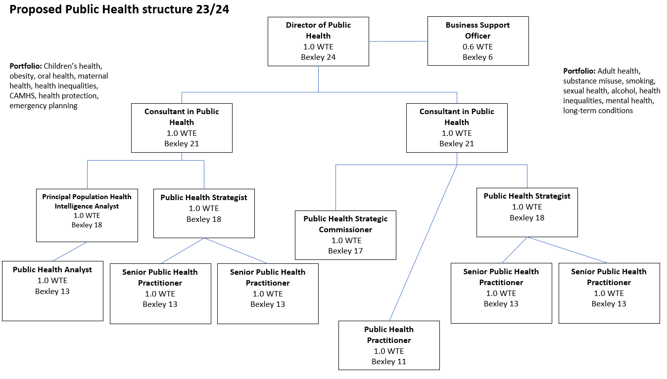
- The Senior Public Health Practitioner will have no management responsibility and will be line managed by a Public Health Strategist who will oversee the post holder’s performance and support the Senior Public Health Practitioner in setting goals, objectives, and training and development as per the Bexley Performance, Wellbeing and Development Scheme. The post holder will report to other members of the team dependent on the project or programmes they are working on along matrix working principles.

6. Additional Information

This is a Public Health post which will provide wide opportunities for developing a public health career, within a Local Authority context.
The post holder will work within a team of public health staff and be expected to have influence over a budget and commissioning, and support the development of public health strategies, policies, and programmes.
The role will be based within a central team but will work with services and managers across all directorates, embedding public health practice across the organisation. The post holder will also be expected to work within project teams that include partnership organisations, e.g., staff from other local authorities, elected Members, the public, external contractors, or any other relevant partners.
Approval - We confirm that this questionnaire conveys a full and accurate description of the job as at (insert date)
Signed:
Manager: ___________Nicole Klynman______________________
Date: ___________________________________________
Post holder: _____________N/A____________________
Date: _____________N/A_______________

Person Specification
Department/Section: Adult Social Care and Health
Job Title: Senior Public Health Practitioner
Selection Criteria | Essential/Desirable (E/D) | Method of Assessment (see key)
(a) Education and formal training  A formal qualification, preferably to a degree level, in a discipline relevant to the responsibilities of Public Health within a Local Authority context, or equivalent work experience.  Master’s in Public Health (MPH) or equivalent related field.  Demonstrated commitment to ongoing professional development. | E  D  E | A  A  I
(b) Relevant technical experience, knowledge & skills/abilities  Experience of tackling health inequalities and delivering related outcomes within local authority and health settings, through direct delivery, commissioning practices, performance management and working in partnership.  Knowledge of commissioning processes, from strategy and policy development, intervention design, procurement to performance management and evaluation  Developing working knowledge of relevant analytical techniques within Public Health, including Population Health Management, and related areas, and proven application of them to a range of situations, including to inform service and strategy design and delivery, and programmes and projects.  Strong verbal and written communication skills, with proven ability to work in partnership across boundaries to influence senior managers and other key stakeholders.  Ability to work within teams within a flexible work environment.  Programme and project management skills, alongside a developing understanding of budget management.  English Language Requirements for Public Sector Workers. Include these criteria where it is an intrinsic and regular part of the role to speak to members of the general public either face-to-face or over the telephone:  - Ability to speak with confidence and accuracy, using accurate sentence structures and vocabulary.  - Ability to choose the right kind of vocabulary for the situation in hand without a great deal of hesitation.  - Ability to listen to customers and understand their needs.  - Ability to tailor your approach to each conversation appropriate to the customer, responding clearly even in complex situations. | E  E  E  E  E  E  E | A/I  A/I  A/I  A/I  I  A/I  A
(c) Other Additional Requirements  Very occasional evening work, for example presenting at key Council meetings or running resident engagement sessions that may be required after usual working hours. | D | I
Working to level 5 in the Skills for Health Career Framework for Public Health | D | A/I

KEY:
I = Interview, A = Application Form, AT = Ability Test, PQ = Personality Questionnaire,
P = Presentation, PE = Practical Exercise, DBS = Disclosure & Barring Service, DL = Driving Licence
Applicants will be assessed against these criteria and the following high-performance indicators throughout the recruitment process.

High Performance Indicators
Values | Behaviours for staff | Behaviours for managers
Innovation | I respond flexibly and adapt to changing demands  I am prepared to take managed risks to achieve better outcomes  I ask ‘What if…? to develop fresh thinking and innovative approaches to generate and implement solutions to improve performance and challenge the status quo | I routinely look for innovative and cost-effective ways to improve performance and customer service  I champion change and deal successfully with ambiguity, enabling people to see positive and exciting possibilities for the future  I take calculated risks based on available evidence and my professional judgement to learn and try new things
Leadership | I demonstrate a clear sense of purpose and direction, in line with organisational objectives  I am willing to take difficult decisions  My personal actions promote a positive image of Bexley | I take responsibility for my service and for making things happen to make a difference to my service users  I create an environment where staff can thrive and show I value and trust staff, give praise and recognise good work  I inspire, lead and encourage staff to move forward
Collaboration | I show respect for others and value contributions from internal and external partners and customers  I recognise the right solution, regardless of who initiated it  I seek out and work with partners who can help me achieve the outcomes and objectives I need to deliver | I encourage the feeling that the team is a collective unit with shared goals  I engage with service partners and other areas of the Bexley organisation to understand the demands on others and seek solutions as One Council  I network internally and externally
Listening and Responding | I acknowledge other people’s viewpoints and work with them to find a win-win solution  I prepare and present information anticipating questions and problems  I adapt my style to the audience and their needs, using the most appropriate communication channels | I seek regular service user feedback and review customer data to shape service improvements  I ask staff for ideas on how to improve our service and how I can improve as a manager, listen to them and act on them  I empower staff to make decisions and changes to improve value for money, customer service and productivity
Open and Accessible | I see issues from the customer / user perspective  I monitor customer feedback and level of satisfaction with the service they receive, and use this to improve and pre-empt customer needs  I seek to build and maintain positive relationships with customers and partners | I am accessible to my service users, customers, staff and Members  I communicate and share a clear vision for the bigger picture as well as specific service areas  I outline what is expected of individuals and their contribution to the whole, and am consistent in my expectations
Impact | I prioritise my activities and resources to focus on those which have the most impact for residents  I take responsibility for making things happen and achieving my objectives  I make decisions and clear recommendations based on my professional opinion and experience, informed by a range of information and evidence | I design services that provide value for money and deliver our outcomes, informed by evidence  I produce, prioritise and adapt plans to meet changing requirements  I set interim goals to achieve notable wins on the way to larger objectives  I deal with poor performance
These HPI values should not be changed.

